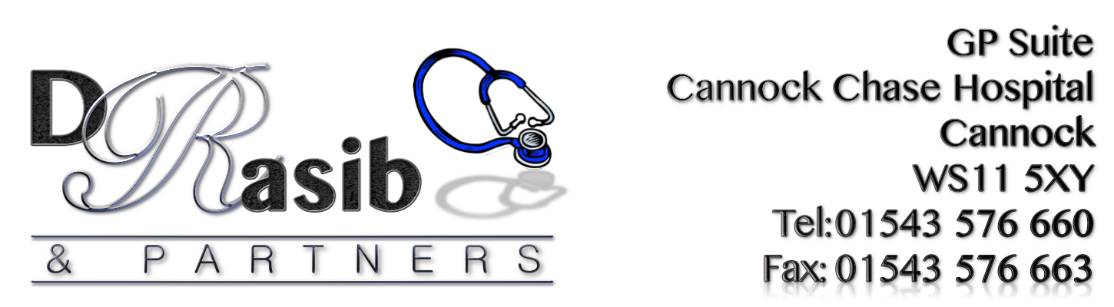

PPG NewsLetter
Winter 2017: Edition 6

Seasonal Greetings
To All

Friday 22nd December: 8.00 – 6.30pm
Saturday 23rd December: Closed
Sunday 24th December: Closed
Monday 25th December: Closed
Tuesday 26th December: Closed
Wednesday 27th December: 8.00-6.30pm
Thursday 28th December: 8.00-6.30pm
Friday 29th December: 8.00-6.30pm
Saturday 30th December: Closed
Sunday 31st December: Closed
Monday 1st January: Closed Tuesday 2nd January: 8.00-6.30pm

The benefits of using Patient Access:-
- Everything is done on line via a computer or a mobile app
- Your repeat prescription can be ordered online so that it is ready for you to pick up from the surgery or you can ask for it to be sent straight to a pharmacy of your choice
- You can pre book on line appointments- non urgent
- Message the GP with health issues - non urgent
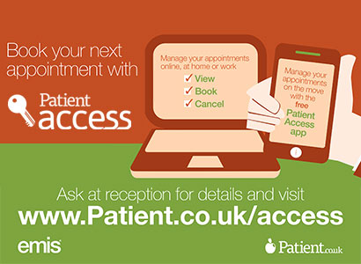
- View some of your medical notes on line

To sign up for Patient Access please contact reception and they will give you the relevant forms and more information.
Important notice to all patients:
Please make sure that you keep all your details up to date
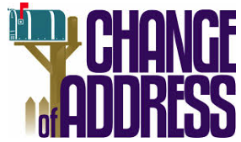
These include:
* Phone Number
* Address if you move house
* Email address if appropriate
* Change of name
* Anything else you think the practice may need to know
You will be required to produce identification for a change of address such as a recent utility bill at your new address
Choose well - Right Treatment, Right Place, Right Time

Do you know where to take your loved ones when they need medical help?
Cannock Chase Clinical Commissioning Group is supporting a national campaign to ensure people know where to go for medical help when they need it.
Too many people are turning up at A&E because they simply do not know where else to go for treatment or what other services are available.
The Choose Well campaign, which is being promoted at GP Practices and community venues across the area, focuses on getting people the right treatment in the right place at the right time.
It aims to help people to understand the different options available and to improve their experience of local health services.

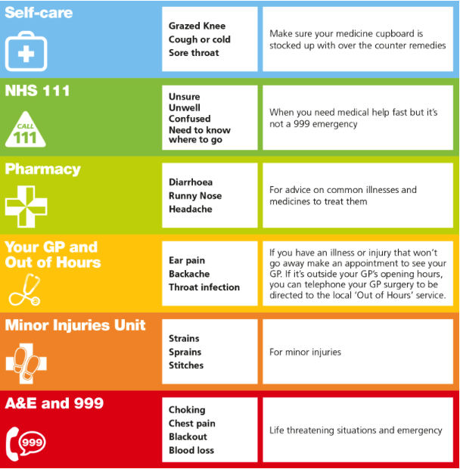

What’s new at the Surgery?
Care Navigation:
Since 1st November, the surgery implemented
The use of Care Navigation to help patients to
‘Get the right care, at the right time, at the right place’ without any delay

How does it work?
- Patients contacting the surgery will be asked for further information regarding their problem.
- Patients will be ‘signposted’ to a member of a multi-skilled team best suited to deal with their problem.
- The patient should be treated, or at least seen by a healthcare professional the same day.
- Surgery staff have received training and will be monitored to ensure patients are handled in the correct way.
NB:
All GP Practices within the Cannock Chase Area will use care Navigation. It commenced on November 1st 2017. This is part of the Governments 5-year forward view plan

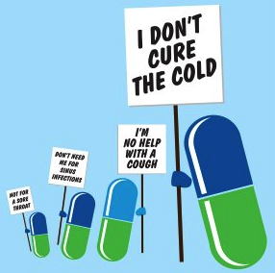
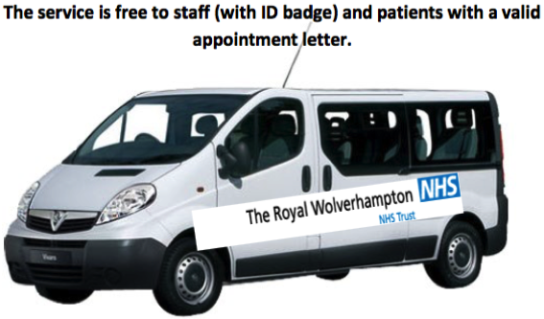
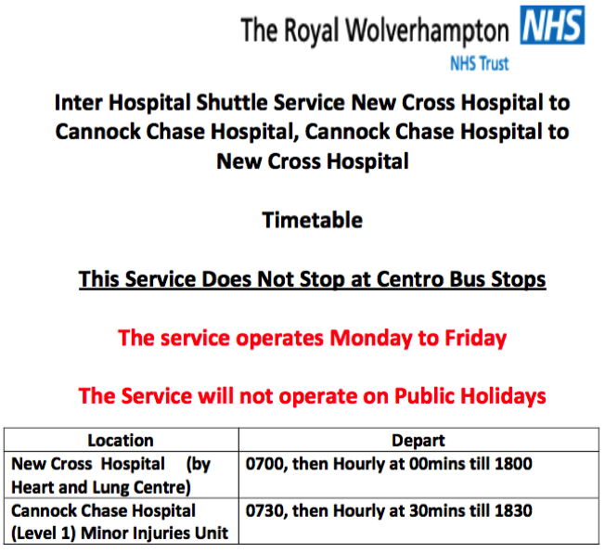
Any Questions? Please ask at reception if you would like any further information
Antibiotic resistance is one of the biggest threats facing us today.

Why it is relevant to you: without effective antibiotics many routine treatments will become increasingly dangerous. Setting broken bones, basic operations, even chemotherapy and animal health all rely on access to antibiotics that work.
What we want you to do: To slow resistance we need to cut the unnecessary use of antibiotics. We invite the public, students and educators, farmers, the veterinary and medical communities and professional organisations, to become Antibiotic Guardians.
Call to action: Choose one simple pledge about how you’ll make better use of antibiotics and help save these vital medicines from becoming obsolete.
Antibiotic Guardian supports the UK Antimicrobial Resistance strategy, European Antibiotic Awareness Day (18 November) and World Antibiotic Awareness Week (13-19 November 2017)
Introducing Walking Football  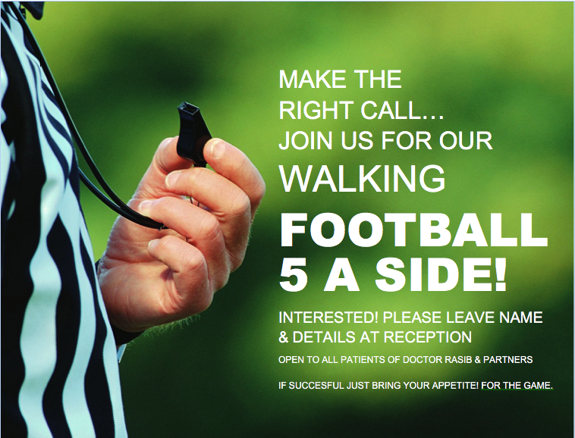  Please get involved  PATIENT QUESTIONNAIRES  Thank you to all patients who gave their time and participated.  The results for these questionnaires will be published in April 2018  Health & Wellbeing  Just give a thought!  Enjoy your celebrations through the festive season, the food and drink you will enjoy, just give the same thought to your care of health and wellbeing.  FLU & PNEUMO VACCINATIONS  FLU JAB! Don’t Come Down With The Flu, Come Down Here For The Flu JAB!  PLEASE BOOK AT RECEPTION  PPG (PATIENT PARTICIPATION GROUP)  Our PPG continues to be a valuable source of information and support for the Practice team.  The next meeting will be held on Wednesday 13th December at 1.00pm at the Practice. If you are interested in joining the PPG, please speak to the reception team. | Emergency & OOH Cover  EMERGENCIES  In the event of a serious problem, such as chest pain or collapse, call 999 immediately.  OUT-OF-HOURS COVER  Medical advice is always available for emergencies at night, weekends and  all bank holidays.  NHS 111  For urgent  & non-urgent advice call 111.  You can also ring  01543 576660  where the recorded message will give you the number for the Out-of-Hours service  STOP PRESS!  DO NOT FORGET THAT WE OFFER TELEPHONE CONSULTATIONS  Thursday evenings  6.30-7.30pm

‘SEASONAL NEW YEAR GREETINGS TO ALL’

If you require this leaflet in any other format then please do not hesitate to speak to a member of the team.

If you have any comments or suggestions about this newsletter or indeed any aspect of the service that Dr Rasib & Partners provides, please feel free to contact the Managing Partner, Sam Rasib on 01543 576660 or in writing to GP Suite, Cannock Chase Hospital, Brunswick Road, WS11 5XY

